# Improving Feature Relevance Analysis Sensor-based Behavioral Context Recognition using Deep Metric Context

# Learning

Dr. Dilli Babu M1*, Vignesh Raj T1*, Vishnu Prasad.V2*, Siddharth.K3*

*\*Department of Information Technology, Panimalar Engineering College, Chennai-600123.* [*vignesh2002raj@gmail.com*](mailto:vignesh2002raj@gmail.com)*1,* [*vishnuprasad45195@gmail.com2,*](mailto:vishnuprasad45195@gmail.com2,%20%20) [*siddhu7656@gmail.com3*](mailto:siddhu7656@gmail.com3)

***Abstract--* The sensors present in commonly used smart devices like wearables and smartphones can collect a vast amount of data on a person's behavior and context. This type of unobtrusive sensing can be helpful in creating solutions for sleep monitoring, assisted living, and fitness tracking. With the increasing integration of sensors in daily use devices, such as the accelerometer, gyroscope, and audio, it's essential to determine if machine learning can identify various real-life activities and contexts by learning from raw signals. To solve this problem, a multi-stream network is proposed to recognize multi-label behavioral context. The network architecture incorporates extracted representations to infer a user's context and contextualizes learning for each modality. Empirical evaluation shows that an end-to-end trained deep network achieves optimal recognition rates. The proposed architecture can be improved by adding more sensors for better performance, and by using multitask learning to handle missing modalities. In order to avoid the ambiguity present in natural languages, the article suggests a logically-based framework for identifying and analyzing behavioral specifications in a formal logic language. To create seamless human-computer encounters, behaviors from sensory data streams must be discovered and formalized as specifications. Understanding how the environment behaves as stated in temporal logic formulas serves as the foundation for accurate and responsive decision-making processes that support reliable, clear-cut decisions for intelligent and context-aware applications.**

***Index Terms -- Differential location privacy, exponential***

***mechanism, mobile crowdsensing, trajectory obfuscation***

1. INTRODUCTION

In modern times, smart spaces are equipped with a variety of sensors and devices that can detect physical stimuli from the environment. These sensors are a critical aspect of context-awareness in smart spaces, which involves the ability to understand changes in the environment and respond appropriately. Context can refer to any information that characterizes a situation involving a person, place, or object. Formal logic is useful for specifying information systems and eliminating ambiguity in descriptions of actions and behaviors. Context recognition is important for many applications, including healthcare and wellbeing, fitness tracking, and user-adaptive services.

Accurately recognizing a person's context requires understanding their physical state,location, and current activity. However, real-world human behavior can vary greatly, making it difficult to develop effective context detection systems. Unobtrusive monitoring is necessary to capture realistic behaviors in a natural environment.

Smartphones and other smart sensing devices, as well as wearables, offer a wealth of data about a person's everyday activities. However, accurate context recognition may be hampered by the variety of utilization patterns, environments, and device types. The system's ability to recognize objects can be enhanced by learning disentangled models from a large-scale data source and combining sensory modalities.

1. LITERATURE SURVEY

Muhammad Ehatisham-Ul-Haq , Muhammad Awais Azam , Yasar Amin and Usman Naeem[1] in their work “C2FHARThe implementation of smart sensing devices equipped with a range of sensors, including motion sensors, has enabled the constant and unobtrusive monitoring of human activities. This is particularly useful for ambient assisted living, and has led to the development of a method called "Coarse-to-Fine Human Activity Recognition with Behavioral Context Modeling," which uses smart inertial sensors. While there has been successful research in this area, accurately recognizing human activities in real-time remains a challenge due to the impact of behavioral contexts on physical activity patterns. This study suggests C2FHAR, a novel approach to human activity recognition in-the-wild that models users' behavioral contexts with daily activities to recognize fine-grained human activities, in order to allow context-aware and knowledge-driven applications in real-time. The proposed approach uses a multi-label classification model to identify human activities at both coarse and fine-grained levels, depending on the real-time use-cases. The approach is tested with various sensors and validated with extensive experiments, showing its effectiveness. Ke Wang and Jian John Lu [2] in their work “A Two-Layer Risky Driver Recognition Model with Context Awareness”. Being able to identify dangerous drivers in real-time is essential in preventing traffic accidents in autonomous and intelligent connected vehicles. However, factors outside of the driver's control, like the environment, can significantly impact driving behavior and risk, and gathering this data can be costly. To address this issue, the authors leverage the German Highway Drone Dataset to create models for recognizing hazardous driving behavior and traffic conditions

They assess the likelihood of side collisions and rear collisions using information about car trajectory, classifying high-risk drivers as risky drivers. Vehicle speed, acceleration, and collision risk are all significantly impacted by traffic circumstances, according to the authors .They train six different classifiers to recognize risky drivers and show that their proposed structures significantly improve the models' ability to recognize risky drivers..Bowen Sun, Quanlong Li , Yonghui Guo and Guocheng Li[3] “Context Awareness-Based Accident Prevention During Mobile Phone Use” Over the past few years, people have become increasingly reliant on smartphones due to technological advancements. However, this unhealthy reliance has raised the risk of mishaps and injuries related to mobile phone use. In order to define dangerous contexts mathematically and research accident prevention techniques, this article suggests using data gathered by phone sensors and context-aware technology. The study is divided into three sections. human behavior awareness, spatial position awareness, and interactive awareness. Dan Stowell, Emmanouil Benetos and Lisa F. Gill[4] “On-Bird Sound Recordings: Automatic Acoustic Recognition of Activities and Contexts” They present a new approach to studying animal behavior and the environment in which it occurs, using microphone backpacks attached to the backs of individual birds in flight. While these devices are typically used to study vocalizations, they can also record other sounds and activities that occur simultaneously.Xiaohan Li , Wenshuo Wang , Zhang Zhang and Matthias Rtting [5] in their work "Analysis of naturalistic driving data on the effects of feature selection on lane-change maneuver recognition "The purpose of this study is to propose a feature selection method to improve machine learning recognition of lane-change maneuvers using naturalistic driving data. With a large number of potential feature candidates, selecting the most effective features is crucial to optimize performance and reduce storage and computation time. Yuhua Wang , Chunhua Wu , Kangfeng Zheng and Xiujuan Wang[6] in their work “Improving Reliability: User Authentication on Smartphones Using Keystroke Biometrics” The use of keystroke biometrics to verify user identity by analyzing their unique behavioral patterns when typing has been widely researched. However,the method's reliability is questionable due to a high error rate and low robustness. To address this issue, this paper proposes a user authentication scheme called DEANUA, which enhances reliability by reducing the error rate and improving robustness. Matthieu Nadini , Peerayos Pongsachai , Chiara Spinello , Daniel A. Burbano-L and Maurizio Porfiri[7] in their work “Empirical Evidence of Upward Social Comparison in a Prisoners Dilemma Game” The social context has a significant impact on individual decision-making, as shown by a substantial amount of research, but the reasons behind people's proclivity for teamwork remain a mystery. The prisoner conundrum is a useful game for studying the factors that lead to collaboration. In this research, participants played a prisoners dilemma game in small groups against computer-generated opponents over a number of rounds. .Zhiyuan Zeng,Jian Tang and Tianmei Wang[8] "Gamification in crowdsourcing projects: Motivation Mechanism" .This essay's goal is to analyze the effects of gaming. on to generated the

participation in crowdsourcing projects. The study proposes a model that explains how different game elements affect different types of motivation, which can in turn affect user participation. The study then collects data through Web experiments and validates the proposed model. The findings indicate that while game elements that generate a fantasy scene may strengthen intrinsic motivation, game elements that give rewards and recognition or remind players of task completion may favorably influence extrinsic motivation."Demographic Bias in Biometrics: A Survey on an Emerging Challenge," by Pawel Drozdowski, Christian Rathgeb, Antitza Dantcheva, Naser Damer, and Christoph Busch[9], is a study on this issue. These systems rely on unique biological or behavioral characteristics of humans to reliably recognize individuals through automated algorithms. However, issues regarding the presence of systematic bias in automated decision-making systems, such as biometrics and facial recognition algorithms, have been raised being a primary focus.Donghong Gu , Jiaqian Wang , Shaohua Cai , Chi Yang , Zhengxin Song , Haoliang Zhao , Luwei Xiao and Hua Wang[10] in their work “Targeted Aspect-Based Multimodal Sentiment Analysis: An Attention Capsule Extraction and MultiHead Fusion Network ”The analysis of emotions using multiple modes has become important in many fields. To analyze emotions, various modalities are used to examine different aspects of a single target. This research suggests a network called the attention capsule extraction and multi-head fusion network (EF-Net) to carry out this task and introduces targeted aspect-based multimodal sentiment analysis (TABMSA) for the first time. Multi-head attention (MHA) and ResNet-152 are used to process the text and image data independently, and the MHA and capsule network are combined to capture interactions between the various processing modes.

1. EXISTING SYSTEM

Individuals frequently need to exchange their sensing information and associated locations when taking part in mobile crowdsensing activities. However, since attackers can use data analysis methods to extract a user's trajectory features, current location privacy-preserving mechanisms fall short in protecting users' trajectory privacy. This article suggests a mechanism dubbed the "differential location privacy-preserving mechanism based on trajectory obfuscation" to address this problem. (LPMT). In order to extract trajectory features, LPMT first finds stay points using a sliding window algorithm. The exponential method is then used to obfuscate each stay point to a target obfuscation subregion. To obtain the obfuscated GPS points, LPMT conducts Laplace sampling in the target obfuscation subregion. LPMT offers stronger security and a higher quality of service compared to baseline mechanisms, obfuscation quality is maintained while decreasing data quality loss by more than 20%. During the process of extracting trajectory features, In the user's trajectory, LPMT recognizes stay points as features and generates regions and subregions for obfuscation. A stay point refers to a specific spatiotemporal location where a user remains for a duration greater than or equal to a predetermined threshold, which may compromise their privacy. Then, to create possible obfuscation subregions, LPMT creates an obfuscation region for each original stay point and splits it into several subregions of equal size. These obfuscation areas and subregions are created for the following reasons.

Assume that the trajectory's stay points fit into the stay point category in Figure 3, which shows a stay point with a uniform distribution of sampled points. In this case, clustering the sampled locations would allow the attacker to collect the trajectory characteristic. The location context similarity data is in advance retrieved from the data center during the stay points obfuscation phase, allowing the present system to focus on SPOA. Each stay point is traversed by the SPOA algorithm, which then employs the exponential method to choose a target obfuscation subregion for every stay point.

1. PROPOSED SYSTEM

The main focus of this study is to improve the recognition of human activities using data from inertial sensors that are collected by smartphones. While many wearable devices already exist on the market that rely on sensor data, most of these devices use pre-built algorithms that are static in nature and cannot adapt to new and unforeseen situations. Unfortunately, this approach assumes that the data structure remains constant over time, which is not always the case in the real world where situations are constantly changing. Therefore, personalized models that can adapt to individual users are becoming increasingly important.

The study introduces a systematic and reproducible approach to selecting and annotating fine-grained activities using the Extra Sensory dataset. This dataset includes primary activities and related context labels, but unfortunately, these context labels are not always consistent for all users. This makes it challenging to accurately label activities in a way that is personalized and adaptive to individual users. However, By examining the co-occurrences of primary activities with various behavioral contexts and phone positions, the research makes an effort to overcome this difficulty. By understanding the relationship between these variables, the study aims to develop a more accurate and personalized system for recognizing human activities.

Each user in the Extra Sensory dataset has six main activities, and it also offers a sizable number of binary secondary context labels. These context labels offer crucial details regarding the behavioral contexts that exist when a specific primary action is carried out in the wild. However, because the dataset was collected in an in-the-wild setting, the context labels are not consistent for all users. Consequently, accurately labeling fine-grained activities that incorporate both primary ADLs and behavioral context information is not a straightforward task.

To integrate contextual information into ADLs, it is essential to rename these activities based on the users' social or behavioral context in their everyday surroundings. In this research, To better understand how the selected ADLs are related to various behavioral contexts and phone positions, the Extra Sensory dataset was thoroughly examined. By conducting this analysis, The frequency at which different behavioral contexts and phone positions are combined with each main activity in a was determined by

the researchers By using this personalized approach, the study hopes to improve the recognition rates of human activities and reduce errors caused by static, pre-built algorithms that are not adaptive to individual users.

1. IMPLEMENTATION METHOD

**Module 1: Data Preprocessing.**

The first step in data analysis involves two critical processes, data acquisition and data integration. Data cleansing is required to ensure consistency in the data because the data obtained from the actual world is frequently insufficient, noisy, or redundant. To achieve this, redundant data is removed using data cleansing techniques, while missing values are filled through clustering, binning, and regression. In order to ease further processing, data is also combined from various sources, including files and databases. Preprocessing is then carried out to reduce and transform the data in a way that retains its identity and makes it useful for subsequent analysis. This step is vital in removing inconsistent and noisy data, which is crucial in data analysis.

In this research, high-frequency noise, including noise produced by the device itself or by participant movement, may be present in the data gathered from smartphone or smartwatch sensors. A time-domain smoothing filter of order 3 is applied to the data to address this problem and eliminate unwanted noise, which is computationally efficient. Additionally, the window size used in data segmentation is important and depends on the acquisition device's sampling rate and the types of activities that need to be identified. Human activity recognition (HAR) can be completed in a brief amount of time for basic, repetitive activities in controlled environments, but it takes more time for complex, non-repetitive activities to produce accurate results.

The suggested method aims to identify multi-label fine-grained activities (FGAs), which entail complex and erratic patterns, in addition to straightforward ADLs. Therefore, this study proposes a comprehensive approach that integrates data acquisition, data integration, data cleansing, and preprocessing to ensure accurate and reliable HAR.

**Module 2: Feature Processing.**

Usually, feature extraction is employed to recognize significant attributes of prepared data that assist in resolving the classification issue at hand. The accuracy of classification results is directly influenced by the selection of appropriate features. As our HAR (human activity recognition) model aims to distinguish between different patterns of activities of daily living (ADLs) in various contexts, we require a set of robust features. To do this, we used a supervised correlation-based feature subset selection (CfsSubsetSel) approach to perform an empirical investigation of various hand-crafted feature sets used in prior HAR research. By understanding the relationship between these variables, the study aims to develop a more accurate and personalized system for recognizing human activity

**Module 3: Model Training and Behavioral Context Recognition.**

Deep Metric Context Learning Neural Networks typically consist of three layers: input, hidden, and output. These layers are made up of interconnected neurons with nonlinear activation functions, which improve the network's ability to handle nonlinearity. The input layer receives data, which is then analyzed in the hidden layer before the results are passed to the output layer for display. However, due to the network's complexity, it often requires extensive computational processes for training. The ANN structure used in this study has three dense layers and two dropout levels, while the Deep Metric Context Learning Neural Network has five dense layers and three dropout layers

1. ARCHITECTURE DIAGRAM

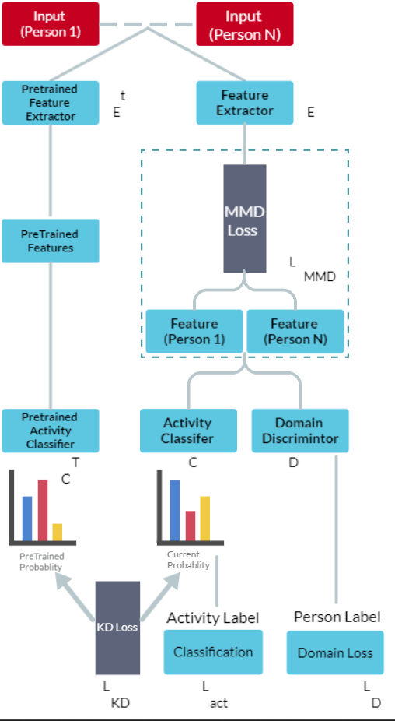



1. EXPERIMENTAL SETUP

The result of the project re-present the recognize of the human behavioral activity with the dataset values

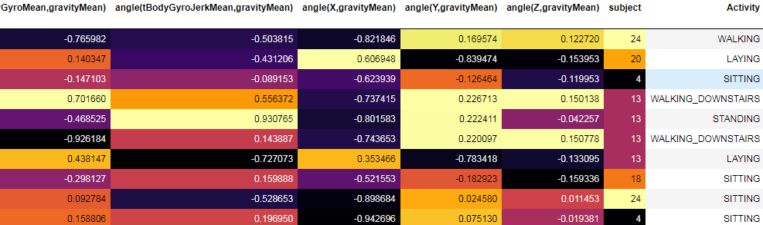With the values the Deep Learning recognize the human activity whether He/She is walking, laying, sitting etc. As show in the above chart

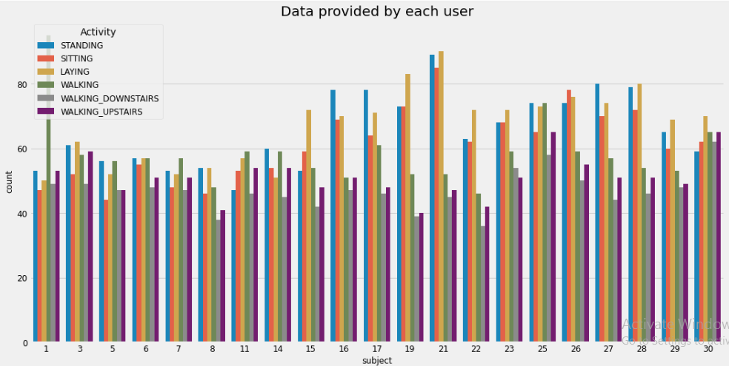

In this bar graph shows the value of the 30 reference from the dataset values. Each reference value show they are differnce from each other.

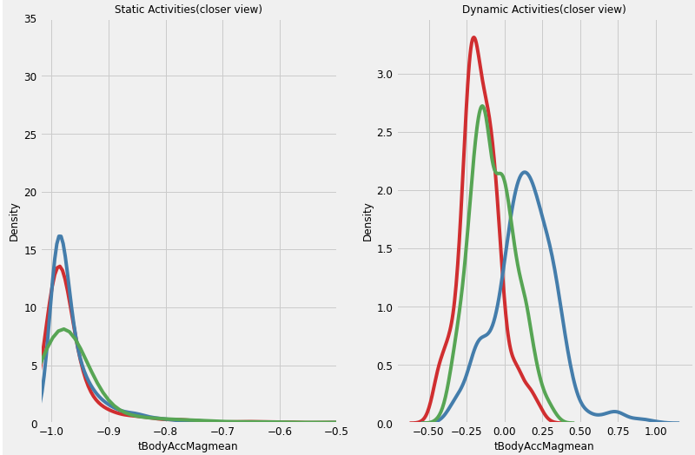

The above graph shows difference in static activities and dynamic activities. As the static activites show the value are constant in minimum range where as in dynamic activittes shows the values are in maximum range.

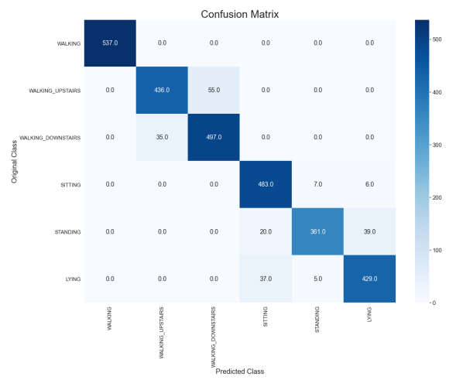

This confusion matrix is evaluate the performance of human activities it compares with what actual activity is done by him or her.

1. CONSLUSION

In order to support proactive decision making, this paper suggests a method for identifying and evaluating behaviors in smart and sensor-based environments. In order to fulfill the recognition process and provide behavioral specifications in the form of logic formulas, the method develops a process for generating logical specifications. The focus is on sensor-based activity recognition, and the authors address the problem of recognizing multiple types of behaviors using deep multi-modal convolutional neural networks. In order to collectively learn from low-level sensory data gathered from smart devices in actual environments, the authors suggest training an end-to-end model. Additionally, they provide techniques for calculating the contributions of representations obtained through various modalities to the accuracy of prediction. The authors show how instance-weighted cross-entropy loss and regularization methods can improve the model's capacity to cope with poorly labeled datasets. Additionally, they show a minor alteration to the proposed network's architecture that uses deep metric context learning to manage missing sensors.

IX. FUTURE WORK

As sensor technology develops, there are several opportunities for more study and development. These possibilities concentrate on enhancing the accuracy and effectiveness of sensor-based systems. Potential research directions include the exploration of novel approaches for handling the complexities of unbalanced multilabel data, making the best sensor choices to minimize computation needs and battery consumption, and combining various comparable sensors to increase the overall detection rate and expand the range of possible uses for sensor-based technologies.

X.REFERENCES

* Y. Amirat, S. R. Fiorini, A. Chibani, F. Attal, and R. Mojarad, "Hybrid approach for human activity recognition by ubiquitous robots," in Proc..
* Human behaviour with mobile health: Smart-, L. Cao, Y. Wang, B. Zhang, Q. Jin, and A. V. Vasilakos, GCHAR: An effective group-based context (D. M. Hilty and S. Chan, Human behaviour with mobile health Recognizing human activity Aug.
* Learning multi-level features for sensor-based human Sep. Y. Xu, Z. Shen, X. Zhang, Y. Gao, S. Deng, Y. Wang, Y. Fan, and E.I.-C. Chang.
* Real-life/real-time elderly p., A. Sucerquia, J. Lpez, and J. Vargas-Bonilla, Apr.
* M. H. M. Noor, Z. Salcic, and K. I. K. Wang published a work in J. Ambient Intell. Hum. Comput. titled "Ontology-based sensor fusion activity recognition" in May.
* Activity recognition invariant to sensor, A. Yurtman and B. Barshan, Aug.
* "Phone position/placement detection using accelerometer: Effect on activity recognition," D. Coskun, O. D. Incel, and A. Ozgovde, Proc. Apr.
* Deep learning algorithms for human activity recognition using mobile and wearable sensor networks: State of the art and research challenges, Expert Syst., H. F. Nweke, Y. W. Teh, M. A. Al-garadi, and U. R. Alo, pp.
* Human activity recognition based on random forests, in Proc, th Int. Conf. Natural Comput., Fuzzy Syst. CA, USA: Morgan Kaufmann. L. Xu, W. Yang, Y. Cao, and Q. Li.
* J. J. Rolison, S. Regev, S. Moutari, and A. Feeney, What are the factors that contribute to road accidents, An assessment of law enforcement views, ordinary drivers opinions, and road accident records, Accident Anal.
* Characterization of motorway driving style using naturalistic driving data, Transp. Res. F: Trafc Psychol., T. H. Itkonen, E. Lehtonen, and Selpi.
* N. Zhao, B. Mehler, B. Reimer, L. A. DAmbrosio, A. Mehler, and J. F. Coughlin, A comparison of the driving behaviour questionnaire with objective indicators of highway driving behaviour.
* N. Zhao, B. Mehler, B. Reimer, L. A. DAmbrosio, A. Mehler, and J. F. Coughlin, A comparison of the driving behaviour questionnaire with objective indicators of highway driving behaviour..